**NavCampus User Manual**

**Table of Contents**

1. Introduction 2
2. System Requirements 2
3. Installation Instructions 2
4. User Interface Overview 2
5. Using NavCampus 3
6. Frequently Asked Questions (FAQ) 4
7. Contacting Support 4
8. **Introduction**

Welcome to the user manual for NavCampus. This document is intended to provide you with all the information you need to use the webapp effectively or help somebody else using it.

1. **System Requirements**

Before using NavCampus please make sure your mobile device meets the following requirements:

Operating system: runs on iOS or Android

Processor: added at a later date

RAM: added at a later date

1. **Installation Instructions**

NavCampus is a webapp therefor there is no need to install it. Just go to the Website: [link] and follow the instructions.

1. **User Interface Overview**

The NavCampus user interface is designed to be intuitive and easy to use. Here's an overview of the interface:

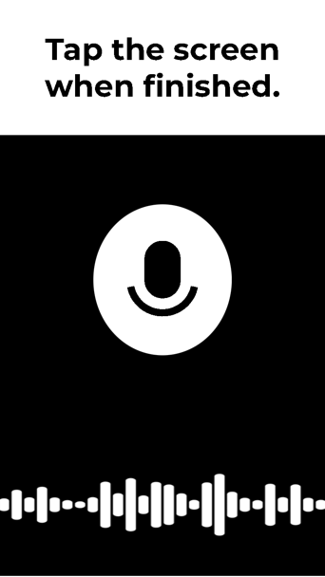

This is the main screen.

Here the user can record an audio to tell the app the destination he/she wants to go to.

1. **Using NavCampus**

To use NavCampus follow these steps:

**Navigation:**

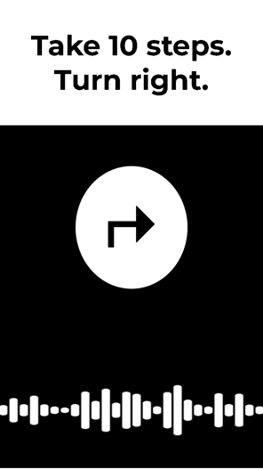 Step 1: go to the page of the WebApp and allow the usage of your device sensors and your phone calls.

Step 2: setting up a destination

1. Tap the screen once
2. The app will tell you to say the destination you want to go to

Step 3: setting up your location:

1. Scan the identifier. These are normally next to classroom doors or next to building entrances. They contain the buildings name and in case of a room the room number. Also they also have braille available, so you know where you are

Step 4: follow the instructions to your destination. Hold the device in a way that the camera is positioned in front of you. Use your cane if you usually depend on it. The instructions will consist of audio instructions as well as arrows on the screen.

Step 5: The app will tell you when you arrive at your destination.

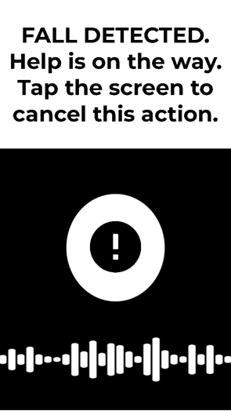

**Fall accident:**

In case you have fallen during your usage of the app. The app will start a timer. To

stop it tap the screen 3 times to stop it.

If you are not able to don’t worry, the app will call for help for you by calling UPD and providing your location.

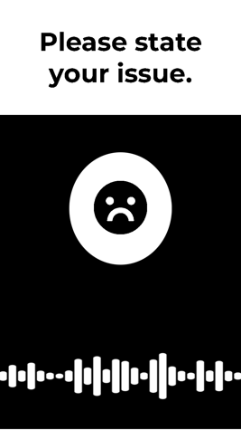

**Feedback:**

Tap the screen 3 times in the normal state (not fall emergency), this will activate the feedback mode.

The system will tell you when it does start recording.

State your issue and when you are finished tap the screen once to stop the recording.

The audio file will be sent to our Team.

Team NavCampus will then investigate ways to make your experience using the app more pleasant.

This use guide shall be available in braille at the advocates office.

1. **Frequently Asked Questions (FAQ)**

Here are some frequently asked questions about NavCampus

Will be added after publication.

1. **Contacting Support**

If you need further assistance with NavCampus please contact our support team at [nk133@humboldt.edu](mailto:nk133@humboldt.edu) or use the feedback feature of the app.